horizontal line

Board Meeting

Date: Wednesday, 3-8-2017, AP&M 6218

# Agenda

## Last Meeting Follow-up

1. ???

## New Business

1. GBM
   1. Updates
      1. Advertising
         1. Print/Cut status
         2. Price (for reimbursement)
      2. Food Planning
         1. TAP form submitted?
         2. Location finalized?
         3. Delivery/setup plans
         4. Utensils etc?
         5. Can you cater to some dietary restrictions?
         6. What exactly will be purchased?
   2. Planning
      1. Need to finalize RSVP form
      2. Email to people that missed the first one should go out now
      3. Facebook event should go up now
      4. Adverts should go up this week
         1. Make a new list of flyer locations
         2. Need volunteers for distribution
         3. Can leave stuff in dropbox at Onestop
      5. Website page description needs to be updated
   3. Content
      1. Why does SUMS exist?
         1. We need a clear purpose, otherwise what we do is murky
            1. Social and Professional

Bring math students together and create a community (hang-outs, bbq, and parrrtaay)

Bring in professionals and professors to give short talk about what they are doing and what people that are interested can do

* + 1. What do we tell people? (Review from last time)
       1. Upcoming Events
       2. Officer Positions
       3. Election Plans

1. Plan Elections
   1. What positions should be made available? What is their purpose? What are the terms? Responsibilities?
      1. Review officer positions: <https://drive.google.com/open?id=0B-o5ELumsfcpdnJrV1pMRFJNNFU>
   2. What is our recourse for officers who don’t work out?
2. Volunteers
   1. What system(s) should be set up so that we can take in volunteers who want to help out with events?
      1. Maybe one officer to be in charge of volunteers?
3. Events
   1. Funding Requests for finalized events
      1. Ones that definitely need to go ASAP:
         1. Math Movie Night: Status?
         2. Latex workshops: March 24th and 31st
         3. Spring Lightning Talks: March 24th
         4. Unknown Social Event: May 7th
         5. Everything after that, we can worry up during Spring quarter.
   2. Math movie night:
      1. Need to decide on a movie soon, we probably want to mention the title at the GBM
      2. Also need some general ideas for structure, food, etc.
   3. Freeform Fridays: Booked, working on ideas
   4. We should review things student requested.
   5. More event possibilities:
      1. Workshops: Ideas
         1. Some kind of coding
            1. R, numpy, octave, opengl
         2. 3D printing (esp. Parametric surfaces)
         3. Career workshop
            1. Talking to professionals (professors, analysts, data scientists, school teachers, engineers)
         4. Other ideas? Do members have workshops they want to do? Can we reach out to other organizations or faculty?
      2. Socials: Ideas
         1. Potluck
         2. Gaming night (Board Games)
         3. Career talks
         4. Cafe night
            1. Hang out with people over some coffee and dessert
            2. Eating off-campus
      3. Integration Bee
         1. We should start booking a room through PC
         2. Forming committees - we should start figuring out who’s interested in what, don’t have to finalize yet:
            1. Funding requests and room booking
            2. Food and Refreshments
            3. Outreach and Publicity

Same as usual- flyers + social media

Also an opportunity to get students/staff involved

* + - * 1. Content and Organization

Come up with problems

Create matching/bracketing system

Keep track of judges and signups

* + - * 1. Roles for day of event

Volunteer judges, scorekeepers, timekeepers, food setup, cleanup

1. Website
   1. New website is up at [sums.ucsd.edu](http://sums.ucsd.edu)
   2. What do we do with [math.ucsd.edu/~sums](https://www.math.ucsd.edu/~sums/)
   3. Issue: old SUMS page has a **lot** of SEO traction, plus a sitemap(?) that makes 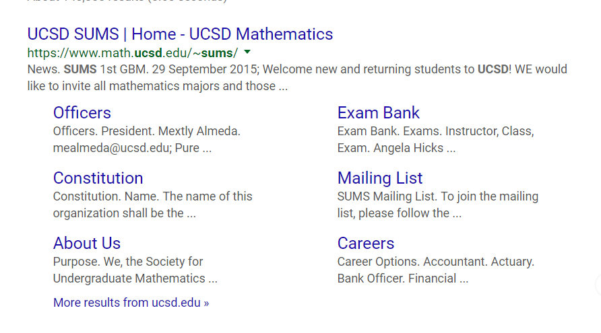the google result nicely formed:
      1. We don’t want to throw away our ranking, what can we do
         1. We can create a link from that page to ours. Or the other way. Whichever is the easier website to control.
   4. Content:
      1. We definitely need more, but the old content was **really** lame.
      2. Ideas?
         1. Contact us
         2. Brief intro (what we do)
         3. Event page
            1. Google calendar
         4. Why math major (career choices)

# Notes

# Action Items

1. Finalize GBM plans
2. Come up with clear plan of how elections will work
3. Determine 2-3 simple, concrete, high-level messages we want to convey at the GBM
4. Set up a plan to submit the rest of the funding requests.

# Next Meeting Agenda Items

1. Finalize May and June events
2. Start thinking about next year
   1. Form 2017-2018 event calendar
   2. How will the handoff process work?